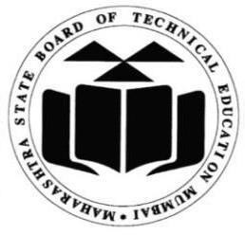

**MAHARASHTRA STATE BOARD OF TECHNICAL EDUCATION, MUMBAI**

## A Report on

**Industrial Training**

## (Internship) (22057)



**Computer Engineering Programme**

## A Report on

**Industrial Training (22057)**



## Submitted by

**Name of Students :-** 1) Deore Samarthya Ravindra

1. Gangurde Suprabha Dinesh
2. Jain Ekta Vinod
3. Makhija Dhruv Harish
4. Patil Rasika Sunil

**Name of Mentor :-** Mr. C. P. Bhamare

**Name of Industry :-** InnovationsHub Services Pvt Ltd.

**Duration :-** 07th Jun 2023 to 22th Jul 2023

## Computer Engineering Programme